**Setting environment for using XAMPP for Windows:** mysql -u root -p

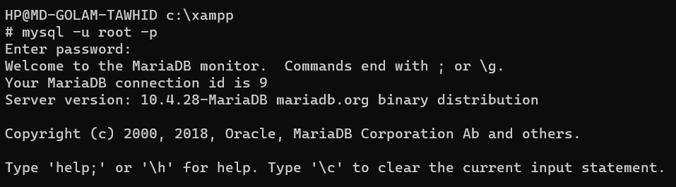

**Showing databases:** show databases;

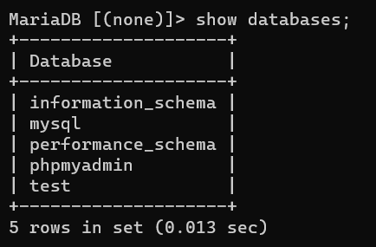

**Creating database for CSE370:** create database CSE370;



**Task 1:**

create table Developers

-> (

-> member_id int,

-> name varchar(30),

-> email varchar(30),

-> influence_count char(6),

-> Joining_date date,

-> multiplier int

-> );

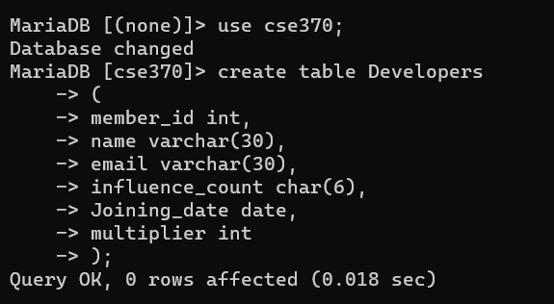

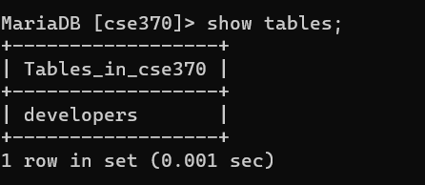

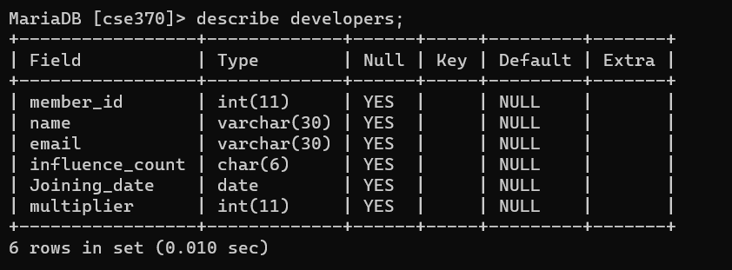

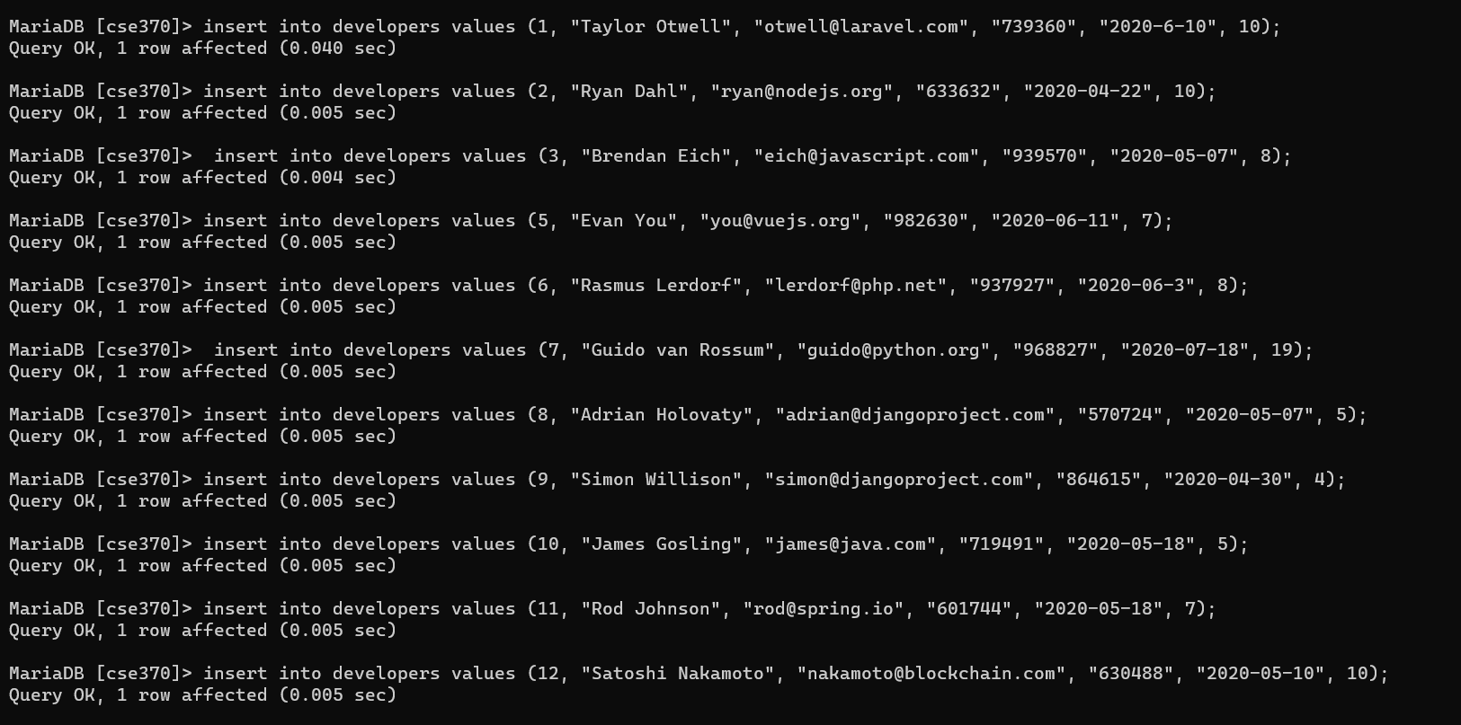

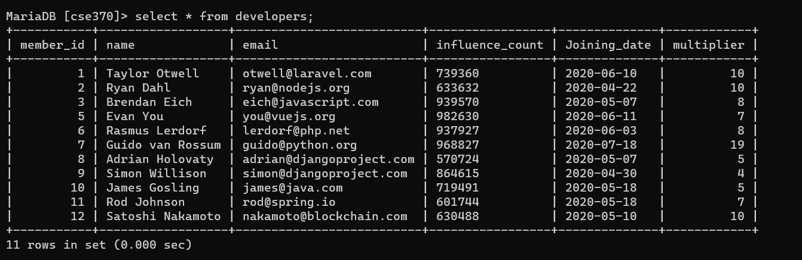

**Task2:** ALTER TABLE developers CHANGE influence_count followers int;

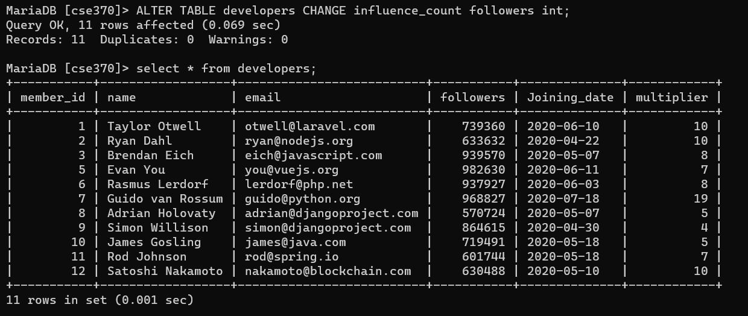

**Task 3:** UPDATE developers SET followers = followers + 10;

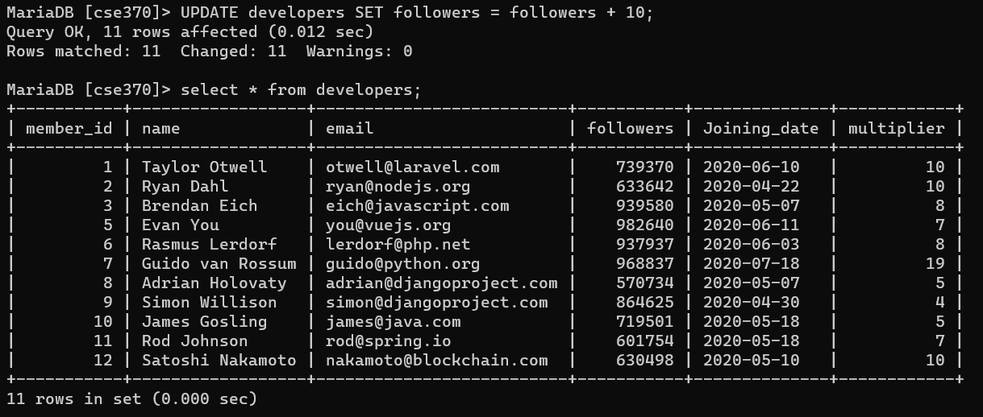

**Task4:** select name,((followers*100/1000000) * (multiplier*100/20))/100 as Efficiency from developers;

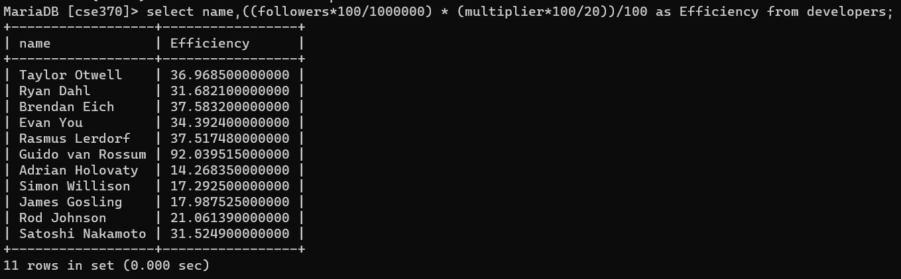

**Task 5:** select name, email from developers order by followers desc limit 5;

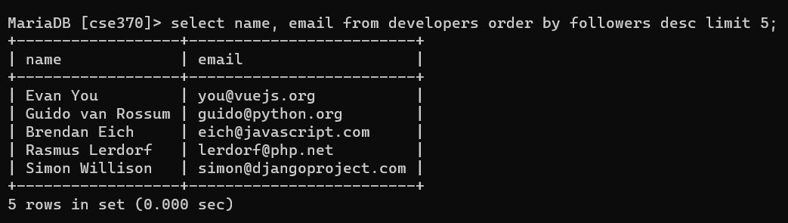

**Task 6:** select name from developers where followers < 700000 and multiplier = (select max(multiplier) from developers where followers < 700000);

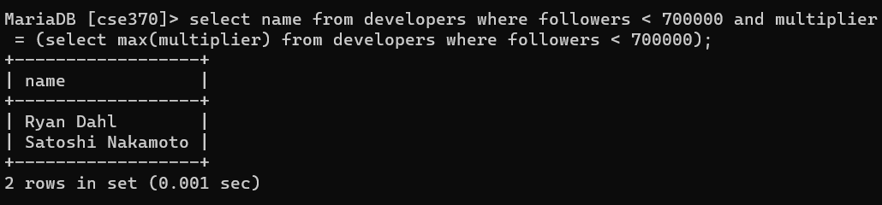

**Task 7:** select avg(followers) as average_followers from developers where Joining_date < '2020-06-11';

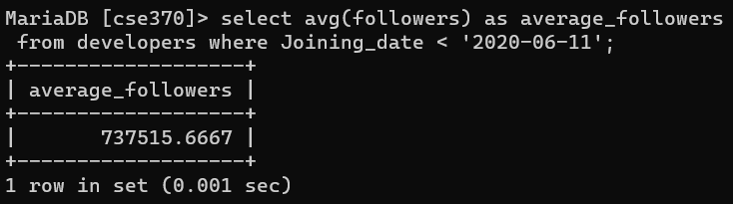

**Task 8:** select member_id,name,email,followers from developers where email like '%.com' OR email like '%.net';

